Dr. Simon Antony Roberts
10/466 Illawarra Rd
Marrickville South, NSW, 2204
simonxaies@gmail.com
+61 434 117 836

NSW Trustee & Guardian
160 Marsden St
Paramatta, NSW, 2150
1300527905@tag.nsw.gov.au
+61 2 8688 2600

07/02/19

To NSW Trustee & Guardian,

This letter is a statement about connecting the service for broadband with optus mobile broadband of the service number 0434141967; we have had problem connecting the service here as the housing department will not for some reason issue us the keys for the manhole as the body corporate making wiring the NBN in completely impossible for all the ISP we have attempt so far.

We then started looking toward mobile broadband and the optus deal they offered us 100GB+100GB bonus seemingly was good to us but at no point of connecting this service was it discussed that there was an over run fee if you went over 200Gb which is where the 700 AUD or so fee came from.

This bill shock is deplorable, seemingly I am also one of the founders of the internet like is stated in all articles on my special access military passport M8747409 which all countries and services with a passport system can access, it is not limited on speciality M; they would be better off sponsoring the link for the return they will get seemingly ultimately TCP/IP is my protocol, it isn’t the public protocol and my external outworld government and galactic senate receive everything single pack sent on the internet and intranet seemingly it was the public TPP protocol that was implemented it was my private communication protocol for palace and home by Vinton Cerf + ICANN.

This is contributing to zoning fee’s each time it is used that you do not have an exchange rata for paying anyway, and is essentially look at the moment like you done this purely as a species for the purpose of spaming our galactic council.

Kind Regards
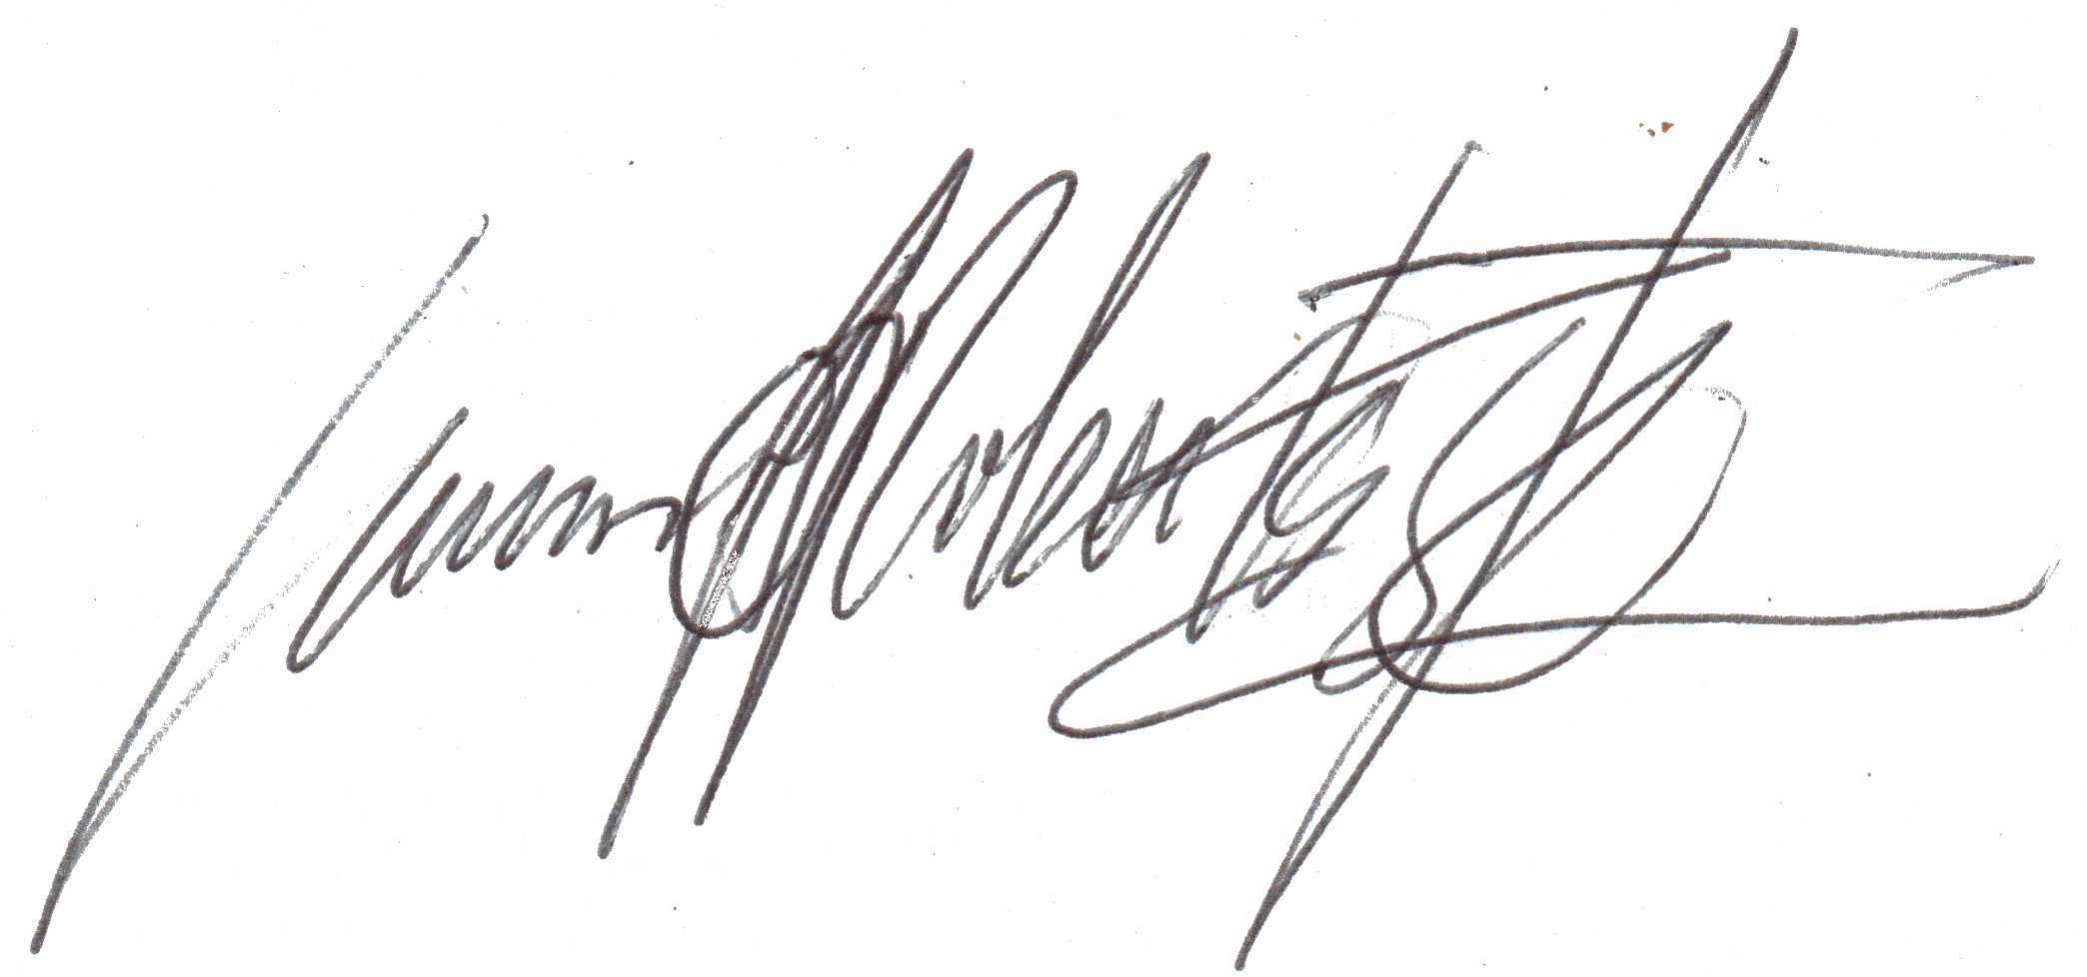

Dr. Simon Antony Roberts
https://internetfounder.wordpress.com

